| Please choose a lesson, or type 0 to return to course menu.

1: Principles of Analytic Graphs 2: Exploratory Graphs

3: Graphics Devices in R 4: Plotting Systems

5: Base Plotting System 6: Lattice Plotting System

7: Working with Colors 8: GGPlot2 Part1

9: GGPlot2 Part2 10: GGPlot2 Extras

11: Hierarchical Clustering 12: K Means Clustering

13: Dimension Reduction 14: Clustering Example

15: CaseStudy

Selection: 1

| Attemping to load lesson dependencies...

| Package ‘jpeg’ loaded correctly!

| | 0%

| Principles_of_Analytic_Graphs. (Slides for this and other Data Science courses may be found at

| github https://github.com/DataScienceSpecialization/courses/. If you care to use them, they must be

| downloaded as a zip file and viewed locally. This lesson corresponds to

| 04_ExploratoryAnalysis/Principles_of_Analytic_Graphics.)

...

|=== | 3%

| In this lesson, we'll discuss some basic principles of presenting data effectively. These will

| illustrate some fundamental concepts of displaying results in order to make them more meaningful

| and convincing. These principles are cribbed from Edward Tufte's great 2006 book, Beautiful

| Evidence. You can read more about them at the www.edwardtufte.com website.

...

|===== | 6%

| As a warm-up, which of the following would NOT be a good use of analytic graphing?

1: To show causality, mechanism, explanation

2: To decide which horse to bet on at the track

3: To show multivariate data

4: To show comparisons

Selection: 2

| You are quite good my friend!

|======== | 8%

| You're ready to start. Graphs give us a visual form of data, and the first principle of analytic

| graphs is to show some comparison. You'll hear more about this when you study statistical inference

| (another great course BTW), but evidence for a hypothesis is always relative to another competing

| or alternative hypothesis.

...

|========== | 11%

| When presented with a claim that something is good, you should always ask "Compared to What?" This

| is why in commercials you often hear the phrase "other leading brands". An implicit comparison,

| right?

...

|============= | 14%

| Consider this boxplot which shows the relationship between the use of an air cleaner and the number

| of symptom-free days of asthmatic children. (The top and bottom lines of the box indicate the 25%

| and 75% quartiles of the data, and the horizontal line in the box shows the 50%.) Since the box is

| above 0, the number of symptom-free days for children with asthma is bigger using the air cleaner.

| This is good, right?

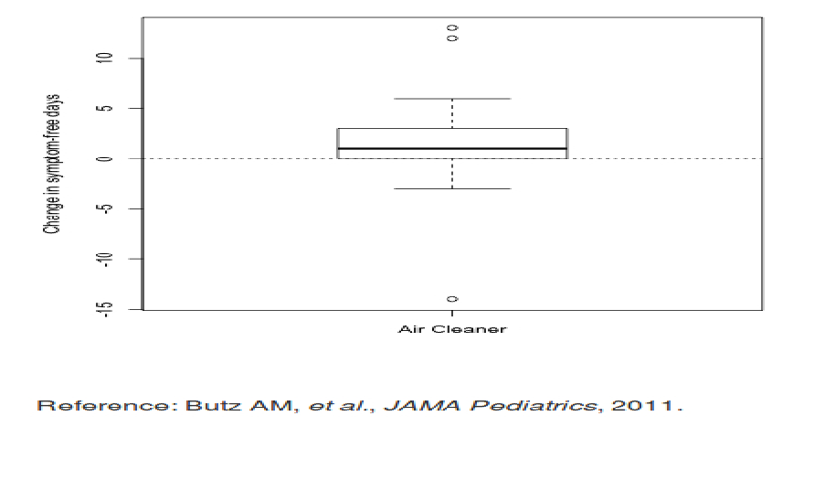

...

|=============== | 17%

| How many days of improvement does the median correspond to?

1: 4

2: -2

3: 12

4: 1

Selection: 4

| You are doing so well!

|================== | 19%

| While it's somewhat informative, it's also somewhat cryptic, since the y-axis is claiming to show a

| change in number of symptom-free days. Wouldn't it be better to show a comparison?

...

|==================== | 22%

| Like this? Here's a graphic which shows two boxplots, the one on the left showing the results for a

| control group that doesn't use an air cleaner alongside the previously shown boxplot.

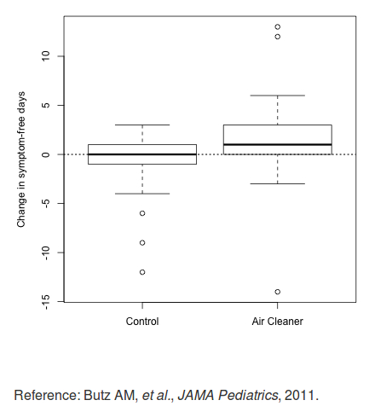

|  |
| --- |
| ...  |======================= | 25%  | By showing the two boxplots side by side, you can clearly see that using the air cleaner increases  | the number of symptom-free days for most asthmatic children. The plot on the right (using the air  | cleaner) is generally higher than the one on the left (the control group).  ...  |========================== | 28%  | What does this graph NOT show you?  1: 75% of the children using the air cleaner had at most 3 symptom-free days  2: Using the air cleaner makes asthmatic children sicker  3: Half the chidren in the control group had no improvement  4: Children in the control group had at most 3 symptom-free days  Selection: 2  | All that hard work is paying off!  |============================ | 31%  | So the first principle was to show a comparison. The second principle is to show causality or a  | mechanism of how your theory of the data works. This explanation or systematic structure shows your  | causal framework for thinking about the question you're trying to answer.  ...  |=============================== | 33%  | Consider this plot which shows the dual boxplot we just showed, but next to it we have a  | corresponding plot of changes in measures of particulate matter. |
|  |
|  |

...

|================================= | 36%

| This picture tries to explain how the air cleaner increases the number of symptom-free days for

| asthmatic children. What mechanism does the graph imply?

1: That the air in the control group is cleaner than the air in the other group

2: That the children in the control group are healthier

3: That the air cleaner reduces pollution

4: That the air cleaner increases pollution

Selection: 3

| Nice work!

|==================================== | 39%

| By showing the two sets of boxplots side by side you're explaining your theory of why the air

| cleaner increases the number of symptom-free days. Onward!

...

|====================================== | 42%

| So the first principle was to show some comparison, the second was to show a mechanism, so what

| will the third principle say to show?

...

|========================================= | 44%

| Multivariate data!

...

|=========================================== | 47%

| What is multivariate data you might ask? In technical (scientific) literature this term means more

| than 2 variables. Two-variable plots are what you saw in high school algebra. Remember those x,y

| plots when you were learning about slopes and intercepts and equations of lines? They're valuable,

| but usually questions are more complicated and require more variables.

...

|============================================== | 50%

| Sometimes, if you restrict yourself to two variables you'll be misled and draw an incorrect

| conclusion.

...

|================================================= | 53%

| Consider this plot which shows the relationship between air pollution (x-axis) and mortality rates

| among the elderly (y-axis). The blue regression line shows a surprising result. (You'll learn about

| regression lines when you take the fabulous Regression Models course.)

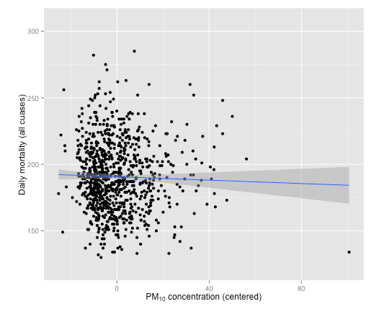

|=================================================== | 56%

| What does the blue regression line indicate?

1: As pollution increases fewer people die

2: As pollution increases more people die

3: Pollution doesn't really increase, it just gets reported more

4: As pollution increases the number of deaths doesn't change

Selection: 1

| You are amazing!

|====================================================== | 58%

| Fewer deaths with more pollution? That's a surprise! Something's gotta be wrong, right? In fact,

| this is an example of Simpson's paradox, or the Yuleâ€“Simpson effect. Wikipedia

| (http://en.wikipedia.org/wiki/Simpson%27s_paradox) tells us that this "is a paradox in probability

| and statistics, in which a trend that appears in different groups of data disappears when these

| groups are combined."

...

|======================================================== | 61%

| Suppose we divided this mortality/pollution data into the four seasons. Would we see different

| trends?

...

|=========================================================== | 64%

| Yes, we do! Plotting the same data for the 4 seasons individually we see a different result.

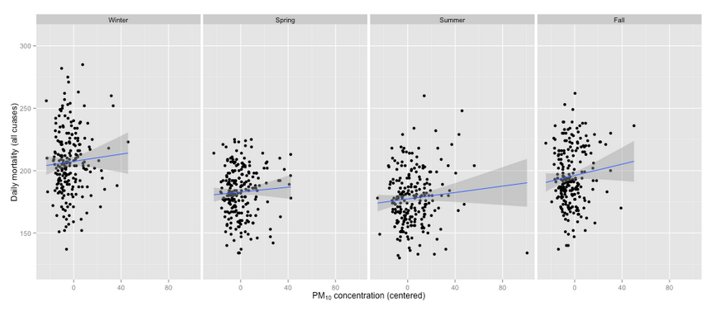

...

|============================================================= | 67%

| What does the new plot indicate?

1: As pollution increases fewer people die in all seasons

2: As pollution increases the seasons change

3: As pollution increases more people die in all seasons

4: Pollution doesn't really increase, it just gets reported more

Selection: 3

| That's correct!

|================================================================ | 69%

| The fourth principle of analytic graphing involves integrating evidence. This means not limiting

| yourself to one form of expression. You can use words, numbers, images as well as diagrams.

| Graphics should make use of many modes of data presentation. Remember, "Don't let the tool drive

| the analysis!"

...

|================================================================== | 72%

| To show you what we mean, here's an example of a figure taken from a paper published in the Journal

| of the AMA. It shows the relationship between pollution and hospitalization of people with heart

| disease. As you can see, it's a lot different from our previous plots. The solid circles in the

| center portion indicate point estimates of percentage changes in hospitalization rates for

| different levels of pollution. The lines through the circles indicate confidence intervals

| associated with these estimates. (You'll learn more about confidence intervals in another great

| course, the one on statistical inference.)

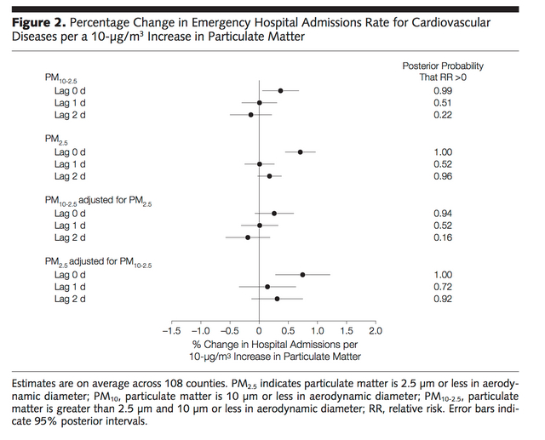

...

|===================================================================== | 75%

| Note that on the right side of the figure is another column of numbers, one for each of the point

| estimates given. This column shows posterior probabilities that relative risk is greater than 0.

| This, in effect, is a measure of the strength of the evidence showing the correlation between

| pollution and hospitalization. The point here is that all of this information is located in one

| picture so that the reader can see the strength of not only the correlations but the evidence as

| well.

...

|======================================================================== | 78%

| The fifth principle of graphing involves describing and documenting the evidence with sources and

| appropriate labels and scales. Credibility is important so the data graphics should tell a complete

| story. Also, using R, you want to preserve any code you use to generate your data and graphics so

| that the research can be replicated if necessary. This allows for easy verification or finding bugs

| in your analysis.

...

|========================================================================== | 81%

| The sixth and final principle of analytic graphing is maybe the most important. Content is king! If

| you don't have something interesting to report, your graphs won't save you. Analytical

| presentations ultimately stand or fall depending on the quality, relevance, and integrity of their

| content.

...

|============================================================================= | 83%

| Review time!!!

...

|=============================================================================== | 86%

| Which of the following is NOT a good principle of graphing?

1: Content is king

2: To integrate multiple modes of evidence

3: Having unreadable labels

4: To describe and document evidence

Selection: 3

| That's the answer I was looking for.

|================================================================================== | 89%

| Which of the following is NOT a good principle of graphing?

1: To show two competing hypotheses

2: To demonstrate a causative mechanism underlying a correlation

3: To prove you're always right

4: Content is king

Selection: 3

| You nailed it! Good job!

|==================================================================================== | 92%

| Which of the following is NOT a good principle of graphing?

1: Content is king

2: To integrate different types of evidence

3: To show good labels and scales

4: To show that some fonts are better than others

Selection: 4

| Perseverance, that's the answer.

|======================================================================================= | 94%

| True or False? Color is king.

1: True

2: False

Selection: 2

| You are quite good my friend!

|========================================================================================= | 97%

| Congrats! You've concluded exploring this lesson on principles of graphing. We hope you found it

| principally principled.

...

|============================================================================================| 100%